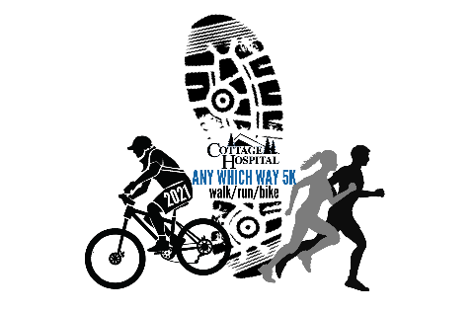
Cottage Hospital’s 1st Annual Any Which Way 5k
Walk-a-thon & Bike-a-thon Pledge Form
Name of Participant__________________________
Address____________________________________ Phone_________________________

Total Raised: _____________
Name | Address | Amount | Paid (cash/check)
Cottage Hospital’s 1st Annual Any Which Way 5k
Walk-a-thon & Bike-a-thon Pledge Form
Name of Participant__________________________
Address____________________________________ Phone_________________________

Name | Address | Amount | Paid (cash/check)
Total Raised: _____________

